Chapter 12 – Marketing & Maintenance: Developing the Community

Marketing
- Promotion
- Sales
- Advertising
- Public Relations

Community Management
- Official Website
- Guides
- Forums
- Newsletter
- Social Media
- Blog
- Wiki
- In-Game Events

Prosumerism: Player as Developer
- Mods
- Fan Art & Fiction
- Fan Sites

Community Is King

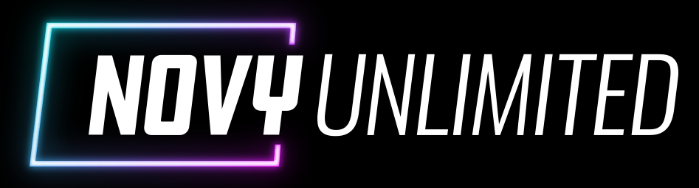 |  | © 2022 Jeannie Novak

